Top bar announcement

example

1. Create the ACF fields

Use an ACF Options Page so the notification is edited once globally, not per page. ACF PRO supports Options Pages through the WordPress admin under ACF → Option Pages.

Create a field group like:

Label | Field Name | Type
Enable notification | top_bar_enable | True / False
Message | top_bar_message | WYSIWYG or Textarea
Button text | top_bar_button_text | Text
Button URL | top_bar_button_url | URL
Background color | top_bar_bg | Color Picker
Text color | top_bar_text_color | Color Picker
Allow visitor to close | top_bar_dismissible | True / False

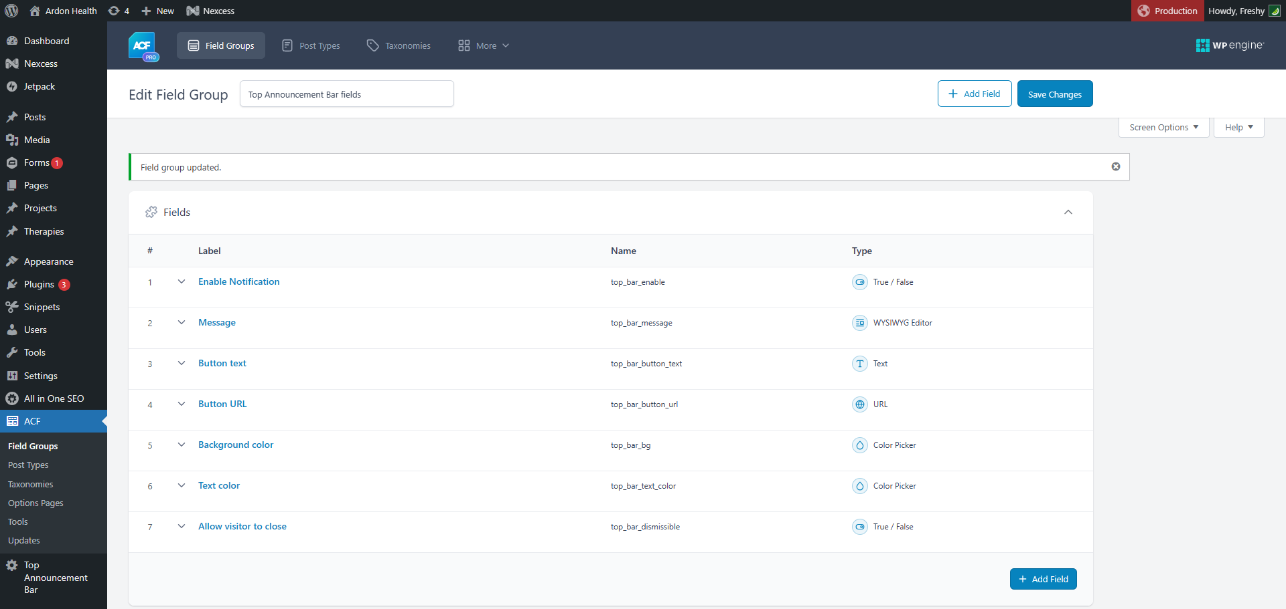

Set the field group location to your new options page.

Backend fulfilled view
Shortcode in code snippets

function freshy_top_bar_notification_shortcode() {
if ( ! function_exists( 'get_field' ) ) {
return '';
}

$enabled = get_field( 'top_bar_enable', 'option' );

if ( ! $enabled ) {
return '';
}

$message = get_field( 'top_bar_message', 'option' );
$button_text = get_field( 'top_bar_button_text', 'option' );
$button_url = get_field( 'top_bar_button_url', 'option' );
$bg = get_field( 'top_bar_bg', 'option' ) ?: '#111111';
$text_color = get_field( 'top_bar_text_color', 'option' ) ?: '#ffffff';
$dismissible = get_field( 'top_bar_dismissible', 'option' );

if ( empty( $message ) ) {
return '';
}

ob_start();
?>

<div
class="site-top-notification"
style="background: <?php echo esc_attr( $bg ); ?>; color: <?php echo esc_attr( $text_color ); ?>;"
>
<div class="site-top-notification__inner">
<div class="site-top-notification__message">
<?php echo wp_kses_post( $message ); ?>
</div>

<?php if ( $button_text && $button_url ) : ?>
<a class="site-top-notification__button" href="<?php echo esc_url( $button_url ); ?>">
<?php echo esc_html( $button_text ); ?>
</a>
<?php endif; ?>
</div>

<?php if ( $dismissible ) : ?>
<button
class="site-top-notification__close"
type="button"
aria-label="Close notification"
>
&times;
</button>
<?php endif; ?>
</div>

<script>
document.addEventListener('DOMContentLoaded', function () {
const bar = document.querySelector('.site-top-notification');

if (!bar) {
return;
}

const closeButton = bar.querySelector('.site-top-notification__close');

if (closeButton) {
closeButton.addEventListener('click', function () {
bar.style.display = 'none';
});
}
});
</script>

<?php
return ob_get_clean();
}
add_shortcode( 'top_bar_notification', 'freshy_top_bar_notification_shortcode' );


Use a code module in a full width row, inside the divi theme builder header
[top_bar_notification]

CSS, adapt as you wish

.site-top-notification {
width: 100%;
font-size: 15px;
line-height: 1.4;
z-index: 9999;
}

.site-top-notification__inner {
max-width: 100%;
width:90%;
margin: 0 auto;
padding: 10px 24px;
display: flex;
align-items: center;
justify-content: center;
gap: 18px;
text-align: center;
}

.site-top-notification__message p {
margin: 0;
}

.site-top-notification__button {
display: inline-block;
padding: 6px 14px;
border: 1px solid currentColor;
border-radius: 999px;
color: inherit;
text-decoration: none;
white-space: nowrap;
font-size: 14px;
}

.site-top-notification__button:hover {
opacity: 0.8;
}

.site-top-notification__close {
position: absolute;
right: 18px;
top: 50%;
transform: translateY(-50%);
background: transparent;
border: 0;
color: inherit;
font-size: 26px;
line-height: 1;
cursor: pointer;
padding: 4px;
}

.site-top-notification__close:hover {
opacity: 0.75;
}

@media (max-width: 767px) {
.site-top-notification__inner {
flex-direction: column;
gap: 8px;
padding: 10px 48px 10px 16px;
}

.site-top-notification__button {
font-size: 13px;
}

.site-top-notification__close {
right: 14px;
font-size: 24px;
}
}



